# ***//Om SRI VEERARAGHAVAYA NAMAHA//***

# ***//JAI MEENA 2//***

Profession and gunas

**By PROF. Satya Sree R, PH.D**.

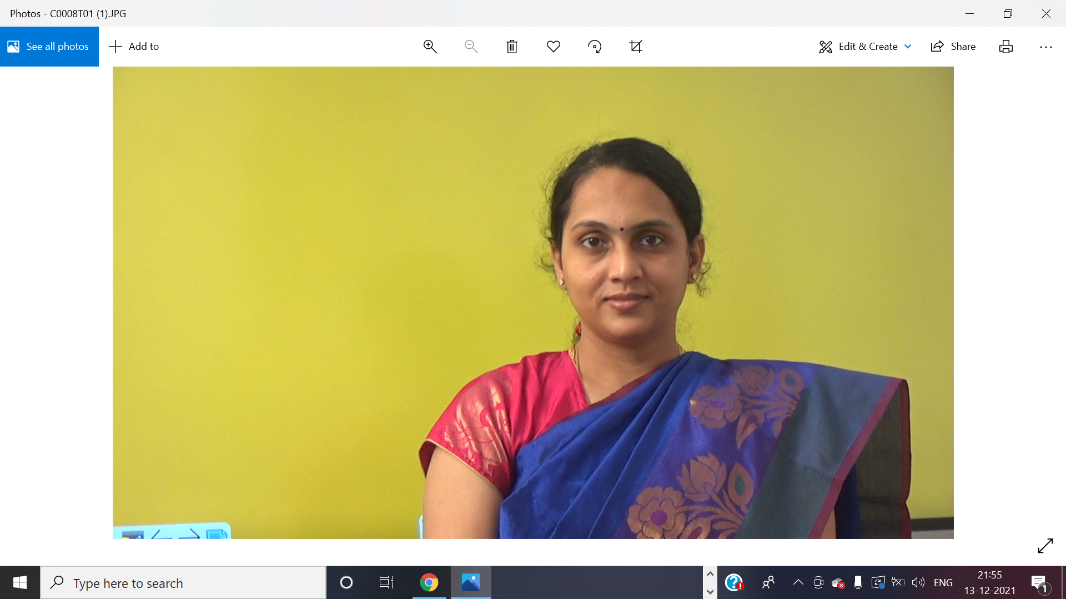*The author has been awarded with Ph.D. in Vedanga Jyothisa from Yoga Samskrutham University for her research on “Stellar Effects – Nakshatra Digbala and Gunas” based on Meena 2 Naadi principles and she has also published a book under the same name based on this thesis. She was also awarded Professorship title recently. She completed her M.A in Vedanga Jyothisa from the same university. She is the founder trustee of JKR Astro Research Foundation. She has also completed her Post Graduate Diploma in Human Resource Management from Xavier Institute of Management, Bhubaneswar (XIMB) and Bachelor of Engineering in Electrical and Electronics Engineering (EEE) from Vasavi College of Engineering, Hyderabad. She has contributed many articles to International magazines and to Light of Naadi Astrology of Meena2 System. She has received many honorary titles like Jyothisa Acharya, Daivagna Ratna, Daivagna Vallabha, Jyothisa Choodamani etc for her contribution towards Meena2 Naadi system.* [*satyasreeraja@gmail.com*](mailto:satyasreeraja@gmail.com)

Profession is one of the most sought-after topics for discussion and the anxiety surrounding this is justified, as one’s profession becomes forms the core for a person’s livelihood & sustenance, their standing in the society, nature of involvement with others and kind of recognition & legacy garnered. Hence, come the flurry of questions on - ‘*What field of profession should I pursue?’, ‘Which stream of education should I take up?’ ‘Will this line of business be beneficial for me?’, so on and so forth.*

In this article, I have explored how to predict the direction and success of one’s career and profession using the theory of Gunas propounded by Param Pujya Guruji Sri N V Raghava Chary (Meena 2) in his Practical Stellar Astrology, popularly known as ‘Meena 2 Nakshatra Siddhantham’. Guruji Meena 2 attaches great significance to the role of Gunas in influencing the nature of results and has hailed Gunas as the ‘future of prediction in Naadi Astrology.’

## A brief on the Gunas Theory

As most of us are aware, there are three gunas as part of our Prakriti which has been prominently explained in depth by Bhagawan Sri Krishna in Srimad Bhagavad Gita – Satwica, Rajasa and Thamasa. Satwica has been identified as goodness, enlightenment and harmony; Rajasa as passion and activity; Thamasa as darkness, ignorance and destruction. All these three gunas are inherent in every human being and cannot be isolated or destroyed. Naadi Granthas have attached importance to Gunas but not much literature had been available or brought forth on the application of Gunas in prediction till the concept was revived by Meena ( 1 and 2) in their work where they very briefly touched upon the concept. Thereafter, Param Pujya Guruji Meena 2 did extensive research on Naadi astrology and took the application of Gunas notches ahead. He was the first and the only person to extensively explain the application of Gunas in predictive astrology. He propounded the 3- step theory of determining Gunas acquired by a planet mentioning that Gunas are not constant but changeable.

In Meena 2 Nakshatra Siddhantha, Mercury and Jupiter are considered Satwica; Sun, Moon and Venus are Rajasic; Saturn, Mars, Rahu and Ketu are Thamasic planets. When planets acquire their own guna, they provide good results, but when Rajasa becomes Thamasa or Thamasa become Rajasa, it is not conducive for good results.

## Profession

In general, profession is primarily signified by the 10th house which indicates the status of a person, line of work, standing in the society. Success in profession is studied in combination with 10th house, 11th house which indicates labha through profession, for instance, income and promotion. The primary karakas for profession are Sun, Jupiter, Mercury and Saturn.

The nature or line of profession can be ascertained by interlinking the gunas and the connected planets to the 10th house. Let us look at a few examples below –

**Chart No 1:**

The native is a scientist. He retired as the Chairman of a leading public sector organization in the aerospace industry. He is known for his contributions to defense research and missile technology. He was closely associated with the then President of India, Dr. APJ Abdul Kalam. He was the recipient of India’s highest awards from the President of India (Visisht and Ati Visisht Seva medals) for distinguished services of exceptional order to the Nation for research and technology development. He received a lifetime achievement award for contributions to science and technology by the President of India through the Aeronautical Society of India. 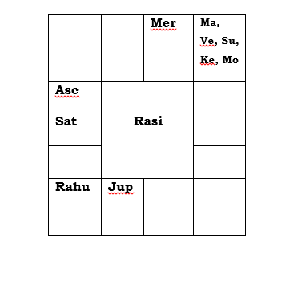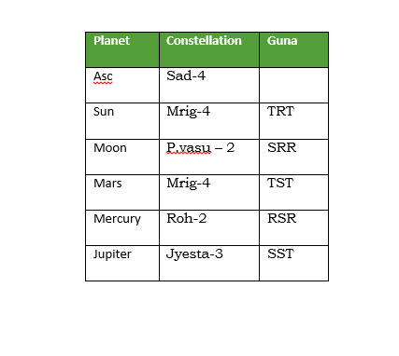

10th Lord Mars is in its own star with Nakshatra Digbala in own Guna with major Thamasa guna. It is in rapt conjunction with 7th Lord Sun, Yogakaraka Venus which are all in Mars star. Mars is already established to be powerful with major Thamasa guna.

10th house occupant is Jupiter which is in major Satwica guna – its own guna. Jupiter also possesses Nakshatra Digbala as it is being aspected by Lagna Lord Saturn. Saturn is also in Jupiter Nakshatra. Lagna and 10th house both become strong through Satwica Digbala of Jupiter. Note also the mutual aspect between Jupiter and Yogakaraka Mercury which is also the dispositor of 10th Lord Mars. Yogakaraka Mercury is powerfully posited in Vargottama Uttama Drekkana with major Rajasa Digbala. Jupiter gains a powerful benefic connection through aspect of Yogakaraka. This mutual aspect brings in a strong influence of Satwica and Rajasa gunas on the 10th house dispensed through benefic planets Jupiter and Mercury. Rajasa guna endows success in ambition, and conquering heights in profession. Satwica guna bestows intellect, desire to contribute knowledge to the benefit of mankind at large and high level of recognition through the 10th house.

We can observe that the 10th Lord Mars itself is quite strong with Thamasa Digbala in the 5th house. A planet gaining its own guna becomes powerful. Here, the 10th Lord is powerful in own guna, and this endowed success to the native in Thamasa related fields of defense and missile research, and helped him flourish in this field.

Let us look at another example:

**Chart No: 2**

The native is high court advocate and a highly successful chartered accountant.

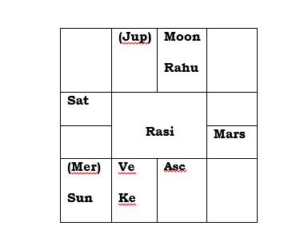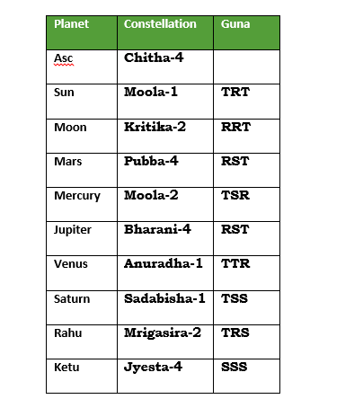

10th Lord Moon is exalted in its own major Rajasa guna (RRT). Hence, Moon becomes powerful. This is aspected by Lagna Lord Venus which is itself powerful with Nakshatra Digbala due to aspect from 4th Lord Saturn. The 10th Lord is also aspected by an exalted Ketu which is in pure Satwica guna (SSS). The star lord of 10th Lord Moon is Sun which is in rapt conjunction with Mercury, both in the star of exalted Ketu which is also powerful with Nakshatra Digbala in pure Satwica guna (SSS). The qualities of Mercury and Sun have enhanced due to the powerful Satwica influence of Ketu. These have transcended into the 10th house. This combination of Mercury, Sun through powerful Ketu (Kujavath Ketu) combination in Satwica guna made each of these connections shine. The combination of Mercury and Sun is also aspected by Jupiter. The native is a successful chartered accountant and a high court advocate.

Gunas play a major role in influencing the nature of results provided by the planet.

Jai Meena 2!

Ref: Practical Stellar Astrology-Sri NV Raghava Chary (Meena2)

Stellar Effects-Nakshatra Digbala-Gunas-Prof. Satyasree Raja PhD